

COMMUNITY COLLEGE OF CITY UNIVERSITY

DIVISION OF APPLIED SCIENCE AND TECHNOLOGY

AST20613 Computer System Development

2014-2015

V. Calendar

(Voice Calendar)

FINAL YEAR PROJECT

ADMIN MANUAL

by

Group:ISD02

WONG, Ho Long(53587834)*

LI, Sing Lun (53612386)

SIN, Sin Chung(53587350)

WONG, Chun Kit(53581516)

Supervised by

Dr. Timothy Kwong

**TABLE OF CONTENTS**

**1. INTRODUCTION**

1.1 OBJECTIVES

1.2 MINIMUM SYSTEM REQUIREMENTS

1.3 RECOMMENDED SYSTEM REQUIREMENTS

**2. SYSTEM FUNCTION**

2.1 ACCOUNT REGISTRATION

2.2 LOGIN

2.3 REGISTRATION

2.4 LOGIN ACCOUNT ADMINISTRATION

2.5 EDIT ACCOUNT

2.6 BACKUP

2.7 RESTORE

**ACKNOWLEDGEMENTS**

1. **INTRODUCTION**
   1. Objectives

This is a guideline to teach administrators how to manage Google Voice Calendar ‘s account function and system running well. The following shows the functions that users can use when they browse the web page with network access.

The following functions supported by our admin system.

1.ACCOUNT REGISTRATION

2.LOGIN

3.REGISTRATION

4.LOGIN ACCOUNT ADMINISTRATION

5.EDIT ACCOUNT

6.BACKUP

7.RESTORE

**1.1 Minimum System Requirements**

Please make sure that the computer on which you plan to be the server of Voice Calendar(VCal) meets the minimum system requirements for the program to run:

* Windows® System XP / XP x64 / Vista / Vista x64 / 7 OS (with the latest Service or updates):
* Intel Pentium 4 1.3 GHz or AMD Athlon XP 1500+
* 1 GB or more of RAM
* 1 GB available hard disk space (for installation)
* 20GB available hard disk space (for system running)
* 4X DVD-ROM drive
* Broadband Internet connection
* Microphone
* Keyboard/mouse NOTE

**1.2 Recommended System Requirements**

* Windows® System Vista x64 / Windows 7 OS:
* Dual-core processor, such as the Intel Pentium D or AMD Athlon 64 X2
* 2 GB RAM
* 2 GB available hard disk space (for installation)
* 60 GB available hard disk space (for system running)
* 4X DVD-ROM drive
* Broadband Internet connection
* Microphone
* Keyboard/mouse

**2.1. Login**

For the login page, users input their username password. There could also provide an option for the users for register their account just before login,the access message for notified the user whether success ed may noticed behinds the login button.

The red blanket refers for the login button,while the blue blanket reflect as the register button,The notified message had bounded by green button while black blankets refers for the user login information. (shown at Figure 2.1)

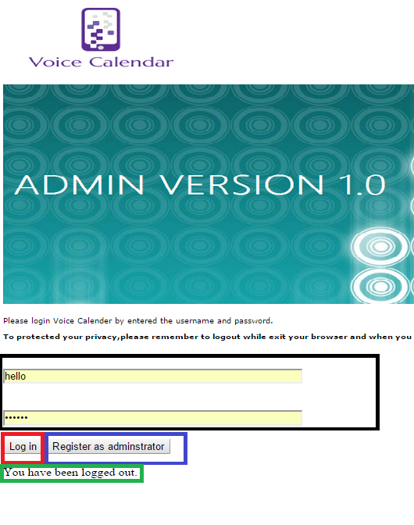

**Figure 2.1 Admin Login Page**

**2.2. Register**

For the register page, users input their username,password,email and repeated password respectively. The users should register their account according to the rule setted from the system,the access message for notified the user whether success ed may noticed behinds the Register button.(red packet).While the green blanket illustrated as back to main pages,the blue blanket refers for the register data from administrators. (shown at Figure 2.2)

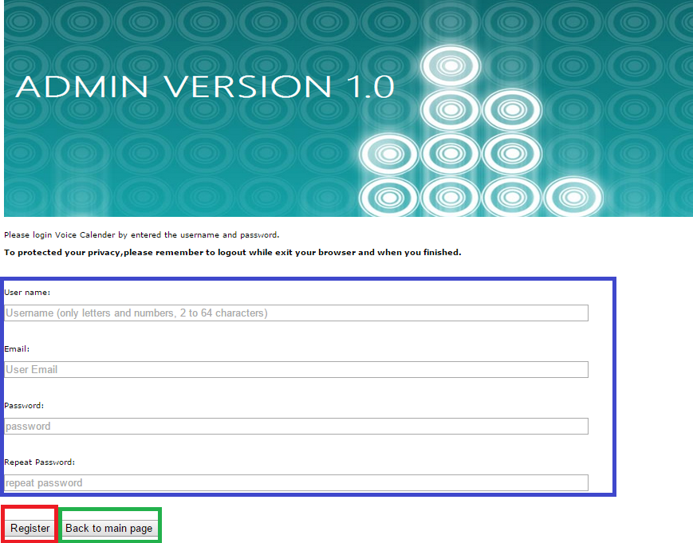

**Figure 2.2 Admin Register Page**

**2.3. Main Page**

For the register page, users input their username,password,email and repeated password respectively. The users should register their account according to the rule setted from the system,the access message for notified the user whether success ed may noticed behinds the Register button.

The red blankets reflects as the nows who login as the administrators for the system,while the green box illustrated the current page that user visited.

(shown at Figure 2.3)

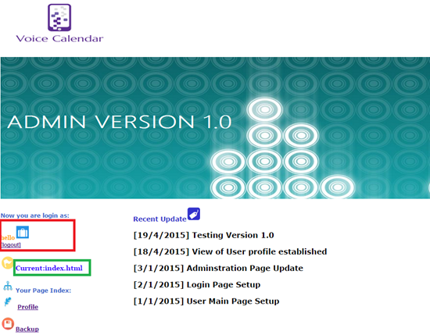

**Figure 2.3 Welcome and Main Page**

**2.4. Account Information Administration**

For the administration page, admin could have the rights for whether edit or delete their events respectively,the allow choice for the user modify their user ‘s name or email while couldn't modify their passwords because of the privacy problem prevention.

Edit button illustrated as black blanket while delete button is illustrated as red blankets.

(shown at Figure 2.4)

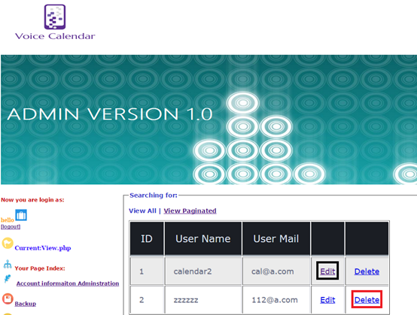

**Figure 2.4 Account Administration Page**

**2.5. Edit Page**

For the Edit page, admin could have the rights for edit the users events ,admin users required to reenter against both name and passwords for information delivery to the database.

The red blankets reflect as user name and user email input for modify their datum while the black blanket illustrated as submit button for modify the database.

(shown at Figure 2.5)

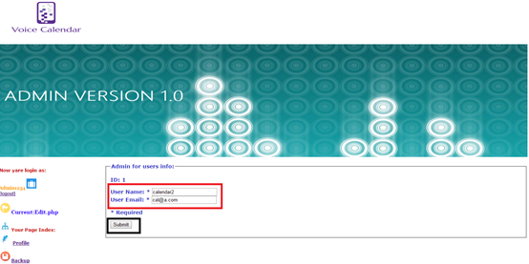

**Figure 2.5 Edit page**

**2.6. Backup Page**

For the Backup page, admin could have the rights for backup the whole system ‘s users information by downloading the sql file.hence,for maintenance system ‘s consistency effectively. (shown at Figure 2.6)

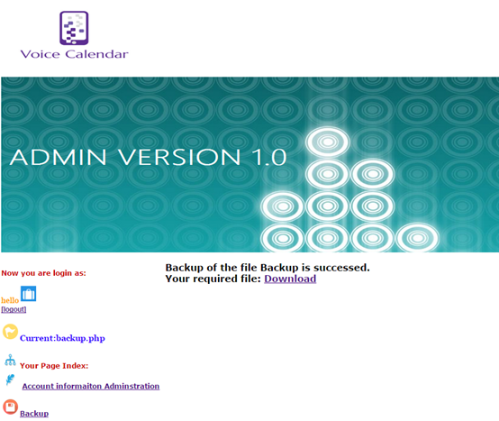

**Figure 2.6 Backup Page**

**ACKNOWLEDGEMENTS**

We have taken efforts in this project, it would not have been possible without the kind help and support of many individuals and organizations. We would like to take this chance to extend our sincere thanks of all of them.

We are very thankful to our supervisor, Dr.Timothy Kwong, the guide of the project that help us to solve many problems throughout the project. Also, we are highly indebted for his guidance and constant supervision as well as for providing necessary information regarding the project and also for his support in completing the project. Moreover, his kind concern provides much power to our team to finish the project successfully.

We would also like to express our special gratitude and thanks to the teachers who have taught us in these two years. The knowledge they have taught us is very useful in this project and it helps to fix lots of issues.

The teachers that we owe a great many thanks are: (Names are listed in alphabetical order)

Dr. Desmond Tsoi

Mr. Frank Lau

Mr. Jackie Kwong

Dr. Kenny Ma

Dr. Timothy Kwong

We would also like to thank you all of our groupmates, with all the help and support for doing the development of the project.

Thank you.

Yours sincerely,

Wong Ho Long, Li Sing Lun, Sin Sin Chung, Wong Chun Kit

FYP ISD-02 V. Calendar